

Consumer-Centered Interoperability

A system for regional and national health records interoperability built around existing web services standards and a patient-centered architecture inspired by the HITSP Consumer Empowerment Use Case.

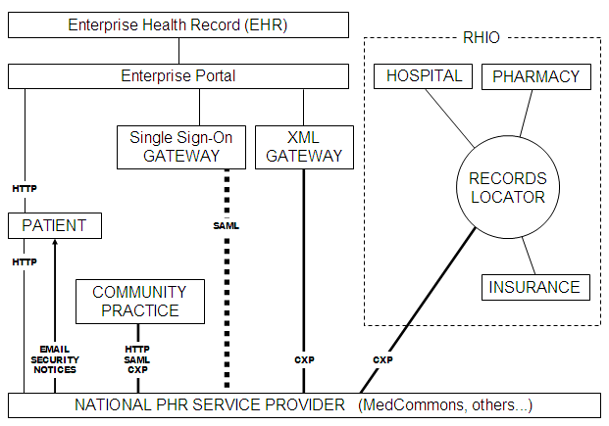

CONTENTS
- Introduction
- A Consumer Perspective on Health Care Interoperability Standards
- CCR Compatible Product Gallery as of January 2006
- MedCommons – A Patient-Centric Exoskeleton for the NHIN
- Federated Identity Management and CXP – MedCommons White Paper – March 2006
- CXP - Commons eXchange Specification 1.0 – March 2006
- HITSP-Consumer Empowerment Use Case – January 18, 2006
- Consumer Reports Investigates Health Privacy – March 2006

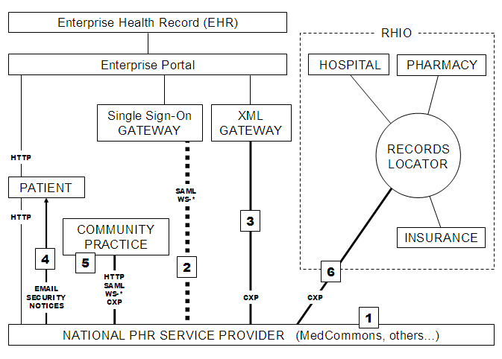

The diagram illustrates how enterprise portals could interoperate with community-based health information resources using open standards and under informed patient consent.

Some of the benefits include:
- Unlike a typical RHIO, MedCommons indexes absolutely no private information and does not participate in master patient index arrangements that are presumed by typical RHIOs.
- Support for two-factor authentication and SAML standard single sign-on provides a strong forensic audit trail for identity assertions across the Enterprise – MedCommons boundary.
- CXP Web service protocol is standards based and transparent to CCR and future XML-based PHR interoperability standards per market demand.
- MedCommons sends simple, privacy-safe emails notices to the patient each time their PHR account is accessed or updated by anyone.
- The patient and community practitioners can access the patient’s PHR using any modern web browser or via CXP-compatible PHR and EHR software.
- MedCommons provides an informed consent mechanism for the patient to forward information to a RHIO.

© MedCommons 2006 except:
CCR Compatible Product Gallery © American Academy of Family Physicians
CXP Protocol and sample code is released under Creative Commons Attribution License 2.5

http://www.centerforhit.org/x1556.xml
http://www.consumerreports.org/cro/aboutus/mission/haveyouheard/yourmedicaldatainbitsbytes0603.htm http://www.consumerreports.org/cro/health-fitness/health-care/electronic-medical-records-306/overview.htm

